**Project Initialization and Planning Phase**

| Date | 12 April 2025 |
| --- | --- |
| Team ID | SWTID1743516636 |
| Project Name | SB Food Ording App |
| Maximum Marks | 3 Marks |

**Define Problem Statements :**

Small food businesses often face challenges in reaching customers and managing orders due to the lack of an efficient digital platform. The SB Food Ordering Website aims to solve this by providing a user-friendly online system where customers can easily browse menus, place orders, and track deliveries. At the same time, it allows vendors to manage menus, handle incoming orders, and view sales reports, ultimately helping small businesses grow their customer base and streamline their food ordering operations.

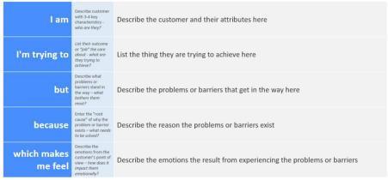

Reference: https://miro.com/templates/customer-problem-statement/

**Example:**

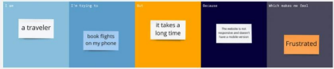

|  |  |  |  |  |  |
| --- | --- | --- | --- | --- | --- |
| **Problem**  **Statement (PS)** | **I am**  **(Customer)** | **I’m trying to** | **But** | **Because** | **Which makes me feel** |
| PS-1 | a hungry customer | order food from local vendors | I can’t find them online | most small food vendors don’t have websites | frustrated and helpless |
| PS-2 | a student living in a hostel | get food delivered quickly | local food isn’t available online | most small eateries don't offer delivery apps | hungry and annoyed |